Techniques to answering Science questions
Name: _______________________ Date: _____________
Questions that ask why a certain animal/thing does not belong in a certain group
Example 1
Study the diagram of the centipede below.
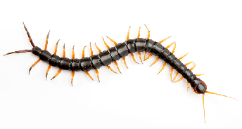
State two reasons why the centipede is NOT an insect.
Students often write:
- The centipede has many legs/more than 6 legs.
- The centipede has many body parts/more than 3 body parts

These answers are WRONG because they are not complete and do not state the characteristics of insects at all.

A complete answer would state the characteristics of insects first, then show that the centipede DOES NOT HAVE those characteristics.

Model Answer:
- All insects have 6 legs but the centipede has more than 6 legs.
- All insects have 3 body parts but the centipede has more than 3 body parts.

Note that the word “but” shows comparison and shows clearly that the centipede is different from the group of insects.

Example 2

Study the table below.

X | Y
light | book
sound | pebble
heat | music

a) Which of the things in the table are classified wrongly?
b) Give a reason for your answer in (a)

Students have no problem identifying “Music” as the answer for part (a).
But they have a problem with part (b)
Students often write:
- Music is not matter.
- Music belongs in the group of non-matter.

These answers are WRONG because the question doesn’t give the heading for the table. Students are expecting the marker to guess which group is matter and which is non-matter.

A right answer would show that music does not have the same characteristics as the other items in the same group.

Model Answer:
- The items in group X are non-matter and group Y contains matter. The book and pebble are matter but not music.
- The book and pebble are types of matter but music is non-matter and belongs with the other non-matter in group X.

Questions that ask what will happen if a certain part is missing/altered.
Example 1
The diagram below shows a seedling.
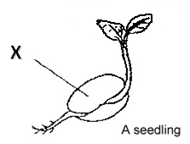

What will happen if part X is removed?

Students will write:
- The seedling will die.
- The seedling will not survive.
- The seedling cannot grow.
These answers are WRONG because this question is looking for the function of X and to see if students know the direct relationship of Part X to the plant’s survival/growth.
A right answer would state the function of X first, followed by the immediate result of removing X.
Model Answer:
- The seedling will not be able to obtain any food from part X and cannot grow/will die.
- The seedling will not have any food to grow as its leaves cannot make food yet.

Example 2

The diagram below shows a bird.
X
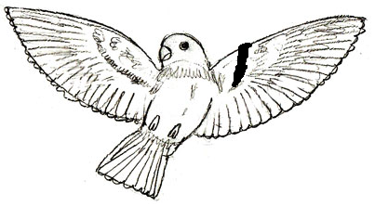

The Bird injured itself at Part X. How will this affect the life of the bird?

Students will write:
- The bird will die.
The answer above is WRONG because students did not consider the function of part X and did not mention anything about the result of injuring part X.
- The bird cannot fly. (partially correct)
The answer above is partially correct. It is good that the students identified that the bird is unable to fly, which is the function of the wings. BUT, the students should add the consequence of not being able to fly.
Model Answer:
- The bird will not be able to fly and cannot escape from predators.
- The bird will not be able to fly around to look for food.

Questions that ask about the aim of experiment
Example 1
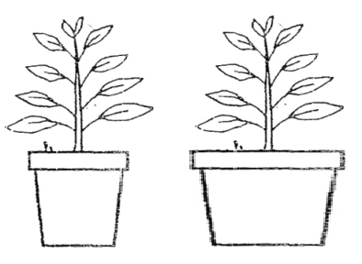
John carried out an experiment as show below. Both plants received the same amount of water and were grown at the same place in the school garden.

John measured the height of both plants after a week.

a) What is the possible aim of the experiment?

Students will write:
- To find out if the bigger pot can grow plants better.
- To find out which pot can grow plants better.
- To find out if the size of the pot affect the growth of the plant.
These answers will be WRONG. As the Aim of experiment depends on the “Changed variable” and the “Observed results”.
Students must also understand that the size of pot determines the amount of soil. Bigger pot = More soil.
A proper answer would have a structure like this:
To find out if ___(changed variable)____ affects the ___(observed results)___.
In this question, it is stated that they were watered the same and were placed at the same place. The picture shows the same plant. The only difference in the set-ups is the size of the pot. So, the ONLY variable that is changed is the amount of soil that the plant has.
The question states that at the end of the week, the height of the plant is measured. This height of plant refers to the growth of the plant. So the observed results is “the growth of the plant.”
So, given that the Changed variable is “the amount of soil” and the observed results is “the growth of the plant”
The Model Answer should be:
- To find out if the amount of soil affects the growth of the plant.
Example 2
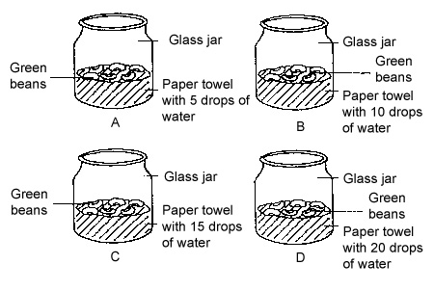
Peter planned an experiment. He labelled 4 similar glass jars as A, B, C and D and put some crushed paper towel into each of them. 6 green bean seeds were then placed on the paper towel in each jar. He placed a different number of drops of water on each of the paper towel. The total number of germinated seeds in each glass jar was counted each day for a week.

What is the aim of Peter’s experiment?
From the question stem, you can see:
Variable Changed: Number of drops of water (Amount of water)
Observed Results: Number of seeds germinated (germination of seeds)
Answer: To find out if the amount of water affects the germination of seeds.
Questions that need you to explain why something happens.

Example 1
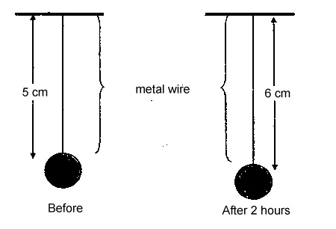
A ball is hung from a metal wire and left under the hot sun for 2 hours. The change in the metal wire is shown below.

Explain why the metal wire became longer after 2 hours in the hot sun.
Students will write:
- The hot sun made the metal wire longer.
- The hot sun heat up the wire and it became longer.
- The wire expanded.
These answers are WRONG because there is no proper terminology/key words used in the answer and it is just stating what happened. The questions requires an explanation.
To explain, the student needs to know that the wire had expanded. However, it is needful to mention WHY did it expand? What made it expand? So what happens when it expands? A good answer usually answers all the HOW? WHY? WHAT? Questions.
Model Answer:
The heat energy from the sun heated up the metal wire, causing it to expand and increase in length.

Example 2
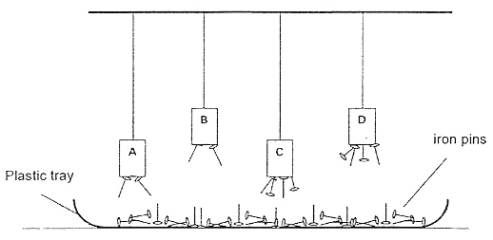
Rahmat uses four similar magnets A, B, C and D to find out which one can attract more iron pins in the set-up below. A plastic tray of iron pins is placed below the magnets and different numbers of pins are attracted to the magnets.

Rahmat concluded that Magnet D is the strongest magnet. Explain why Rahmat made such a conclusion.
Students will write:
- D can attract the most iron pins.
- D can attract pins from the longest distance.

The two above answers are incomplete and untrue. D is the same distance away from B, and C has attracted as many pins as D.

Students need to understand that the strength of a magnet can be seen from the number of pins attracted and the distance away from the pins.
More pins = stronger magnet.
Attract from a longer distance = stronger magnet.

Model Answer:

Magnet D can pick up the most number of pins from the furthest distance.
Questions that ask about the relationship between two things (how one thing affects another)
Example 1
Mary set up two trays of plants. She watered Tray A once a day but watered
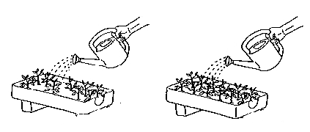
Tray B twice a day. After a week she noticed that Tray B’s plants had more leaves and were growing faster than the plants in Tray A.

Tray A Tray B

From Mary’s Observation, what can you say about how the amount of water affects the growth of plants?

What was noticed, More water = Faster growth.

Students will write:

- If you water the plants more, they will grow fast.
- More water will help plants grow faster.

These answers are not good enough because they do not show a relationship between the amount of water and the growth of plants.

So, putting in words,

Model Answer: The more the plants are watered, the faster they will grow.

Questions that require inference from given data.

Example 1

Mark carried out an experiment using 3 Magnets. He held the magnets the same distance above a tray of iron nails. Then, he counted the number of iron nails attracted by the iron bars and recorded his results in the table below.
 | Magnet A | Magnet B | Magnet C
Number of iron nails attracted | 5 | 0 | 11

a) Based on the information above, which magnet is the strongest? Explain your answer.
b) Give a reason why Magnet B picked up no iron nails.

For (a), Students should infer from the results that a stronger magnet picks up more nails. However, some students might not make use of this understanding in their answer but just state what they see in the results.

Students might write:
- Magnet C is the strongest because it picked up 11 iron nails.
- Magnet C is the strongest because it picks up more nails.
- Magnet C is the strongest because it attracted more nails than Magnet A.

All these answers are WRONG because they either plainly state what is given in the information, or they do not show that Magnet C is the STRONGEST. The answer should clearly state a comparison across all the magnets in the experiment. Use words like “attracted the MOST number of iron nails”.

Model Answer:

a) Magnet C is the strongest because it attracted the MOST/GREATEST number of iron nails.
For (b), students might assume that B is a non-magnet because it picked up NO nails at all. However, they must note that B has been named a Magnet. They cannot assume that B is not a magnet. Instead, they should understand that if the magnet has lost its magnetism or if it is not strong enough, it will not be able to attract magnetic materials well. Inferring from the information, the students should get the idea that Magnet B has lost its magnetism or is not strong.

Students might write:
- Magnet B is not a magnet.
- Magnet B is made of non-magnetic material

- Magnet B cannot attract iron nails
- Magnet B has no magnetism

These answers are WRONG.

Model Answer:

Magnet B might have lost its magnetism and is not strong enough to pick up any iron nails.

Other things to look out for in science questions:

Pay attention to words such as:
- Based on the information above (you have to refer to the information given and not come up with your own reasoning)
- Based on your observation of the diagram (you must give an answer based on what you can see in the picture and not what you cannot see)
- Name the Property/Characteristic/Process/Stage/Part (it is important that you know the difference between these words)
- State the function of … (You must state what is the use of the part/thing)
- What is the purpose of… ( you must state a reason)
- Explain your answer (you must remember to give an explanation)
RICHES
- R- Read
Read the question.
- I-interpret
Understand what the question means.
- C-concept(s)
Think of the concepts required for the question.
- H-highlight
Highlight and identify key words in the question.
- E-elaborate
Ensure that your answer is complete and covers the requirements of the question.
- S-select/solve!
Select the relevant information to solve the question.

R I I - R A C

- Read
Read the question
- Identify Key Words
Identify Words that will tell you what big topic it is about. Identify what the question wants (comparing, inferring, describing, explaining … etc.)
- Identify Topic
The identifying of key words will help you know what topic the question is testing you on. (eg. Properties of Materials, Characteristics of Animals, Germination, Aim of Experiment etc.)
- Recall Information
Knowing the topic will enable you to recall the information needed to answer the question.
- Apply the relevant information
Choose the information you need and apply it to answering the question.
- Check
Check your answer by reading the question and answer to see if you answered the question. Check Spelling. Check if you used correct terms.
Prepared by: Mr Luke Sim

