P4 Mathematics
AA1 Revision

Name: ________________________ Date: _______________
Class: Teamwork 6
Learning objectives: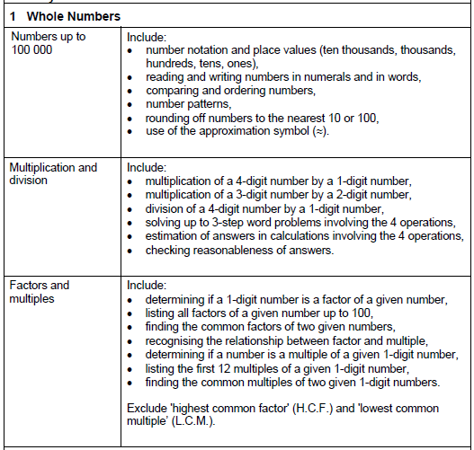

Numbers up to 100 000

- number notation and place values (ten thousands, thousands, hundreds, tens, ones)

- In the number 39 874,
a) The digit _____ stands for 800.
b) The value of the digit 7 is _______.
c) The digit 9 is in the ____________ place.
d) The digit _____ is in the ten thousands place.
e) The digit 9 stands for __________.

- Write the correct number in the blanks.

- 15 tens = _________
- 285 ones = _________
- 23 hundreds = _________
- 2 thousands = _________
- 14 hundreds + 23 tens = ___________
- 34 hundreds + 83 ones = ___________
- 27 tens $÷$ 3 = __________
- 35 hundreds $÷$ 7 = ___________

- reading and writing numbers in numerals and in words,

- Write in numerals:

- Forty-nine thousand, four hundred and twenty-seven. ____________

- Seventy-four thousand and ninety-two. ___________

- Three thousand, three hundred and five. __________

- Thirty thousand and forty-six. ____________

- Twelve thousand, one hundred and thirteen. ___________

- Sixteen thousand and twenty. ____________

- Write in Words:

- 84 194 : _________________________________________________________

- 20 938 : _________________________________________________________

- 36 410 : _________________________________________________________

- 97 578 : _________________________________________________________

- 40 011 : _________________________________________________________

- comparing and ordering numbers,

- Comparing:

Circle the bigger number:

- 39 013 , 31 913

- 48 838 , 84 384

Circle the smaller number:

- 24 127 , 24 172

- 32 323 , 32 232

- Ordering:

Arrange in ascending order:

- 43 443, 34 434, 34 334, 44 343, 33 434

Arrange in descending order:

- 91 319, 93 193, 39 139, 91 391, 91, 139

- number patterns,

- Fixed increase/decrease

- 12 345 , 13445 , 14 545 , __________ , ___________ , 17 845

- 34 998 , 32 988 , 30 978 , _________ , 26 958 , ___________

- Alternating Increase/decrease

- 10 010 , 12 010 , 11 510 , 13 510 , _________ , __________

- 72 395 , 72 695 , 71 695 , 71 995 , _________ , __________

- Other patterns…

- 32 541 , 33 541 , 35 541 , 38 541 , _________ , ___________

- 41 538 , 40 537 , 39 535 , 38 532 , _________ , ___________

- rounding off numbers to the nearest 10 or 100,

- Rounding off to nearest 10: Rounding off to nearest 100:

- 13 525 ≈ _________ e) 53 852 ≈ _________

- 398 ≈ __________ f) 9 731 ≈ _________

- 72 894 ≈ __________ g) 8 989 ≈ _________

- 8 231 ≈ __________ h) 42 989 ≈ _________

- use of the approximation symbol ≈

- Round off to the nearest hundred first then estimate the value of:

- 3 429 + 2 283

- 49 019 + 396

Multiplication & Division

- multiplication of a 4-digit number by a 1-digit number,

- Solve the following questions. Show your working clearly.

- 3 248 x 7 = __________ b) 7 459 x 8 = ___________

- There are 2345 toothpicks in a box. How many toothpicks are there in 6 such boxes?

- A factory bakes 1079 buns in a day. How many buns can it bake in 4 days?

- multiplication of a 3-digit number by a 2-digit number,

- Solve the following questions. Show your working clearly.

- 243 x 14 b) 987 x 54

- There are 264 sweets in a bag. How many sweets are there in 35 bags?

- division of a 4-digit number by a 1-digit number,

- Solve the following questions. Show your working clearly.

- 9 863 $÷$ 4 b) 5 547 $÷$9

Quotient: _________Remainder_____ Quotient: _________Remainder____
- There are 2344 students in a school. They are put into 8 groups. How many students will there be in each group?

- 4319 cookies are put into packets of 6.
i) How many packets are there?
ii) How many cookies are left over?

- determining if a 1-digit number is a factor of a given number,
(A number can be divided by its factor without having a remainder)
Q. Is 6 a factor of 96? Take 96 $÷$ 6 to find out.

- listing all factors of a given number up to 100,

- List all the factors of:

- 37 : ________________________________________

- 24: _________________________________________

- 46: _________________________________________

- 72: _________________________________________

- finding the common factors of two given numbers,

- Common factors

- Find the common factors of 24 and 32.

Common factors:_____________________________________________

- Find the common factors of 48 and 72.

Common factors:_____________________________________________

- recognising the relationship between factor and multiple,

36
1 x 36
2 x 18 36 is a multiple of 1,2,3,4,6,9,12, 18 and 36.
3 x 12
4 x 9 1,2,3,4,6,9,12, 18 and 36 are factors of 36
6 x 6

- determining if a number is a multiple of a given 1-digit number,

To find if a number is a multiple of a given number, it must be divisible by that number.

E.g. Is 36 a multiple of 9?

Yes, because 36 can be divided by 9 without remainder.

- listing the first 12 multiples of a given 1-digit number,

- Listing/Identifying Multiples

- List the first 12 multiples of 7:

- What is the 6th multiple of 9? ________

- What is the 8th multiple of 5? ________

- What is the 7th multiple of 6? ________

*part (b), (c) and (d) require no listing

- finding the common multiples of two given 1-digit numbers.

- Common Multiples

- NOTE:

Once you find the first common multiple, you can find all the other common multiples because the other common multiples are MULTIPLES of the 1st common multiple which you found.

- List the first common multiple of 7 and 4

- List the first 3 common multiples of 4 and 6

- List the first 5 common multiples of 3 and 5

Prepared by: Mr Luke Sim
-End-

