Morning Remediation
Primary 4 Science
Aim of Experiment / Variables

Name: ________________________ ______ Date: ________________

A. Finding Aim of Experiment
To find the Aim of Experiment, you need to know the variable that is changed (changed variable) and the results that you will be observing at the end of the experiment.(Observed result)
The structure of the Aim of experiment is usually:
To find out if __(changed variable)____affects ____(observed result)______
Example:
Kenneth keeps two fishes in separate tanks. He feeds the fish in Tank A once a day and feeds the fish in Tank B twice a day. He measures the length of the two fishes after two weeks.

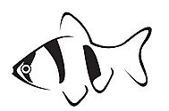

Tank A – Feed once a day Tank B – Feed twice a day
a) What is the possible aim of his experiment?

Changed Variable: amount of food fed to the fish
Observed Result: the size of fish / the grown of fish

a) To find out if the amount of food fed to the fish affects the growth of the
fish.

Remember: all variables are to be kept the same except the variable you are testing.
1. Gabby grew two identical plants in pots. She kept one in the garden and kept one in the house. She gave both plants the same amount of water. At the end of the month, she measured the height of both plants. She found that the plant grown in the garden was taller than the plant grown in the house.

a) What was the aim of her experiment?

________________________________________________________________

________________________________________________________________

b) Give a reason why the plant in the house did not grow as fast as the plant in the garden.

________________________________________________________________

________________________________________________________________

2. Harry used 4 magnets of different length to attract paper clips from a box. Each magnet is of the same thickness. He lowered each magnet into a box and then counted the number of paper clips attracted to each magnet after it was taken out. His observation is recorded below.
Magnet | No. of paper clips attracted
A | 23
B | 15
C | 9
D | 42

a) What is the aim of Harry’s experiment?
________________________________________________________________
_______________________________________________________________
b) From the results obtained, order the magnets A, B, C and D from the strongest magnet to the weakest magnet. (write A, B, C and D in the boxes)
Strongest
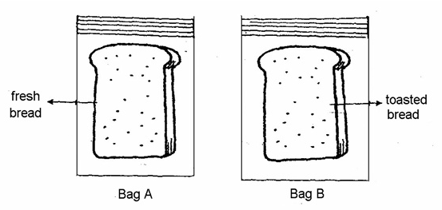
3. Ahmad prepared two set-ups as shown below.

The bread in Bag B was toasted until there was no more moisture left in it. Ahmad kept the bags in the cupboard for two weeks then observed the amount of mould growing on each piece of bread. The bread in Bag A showed a few dark patches of mould but there was no mould on the bread in Bag B.
What is the aim of his experiment?
________________________________________________________________
________________________________________________________________
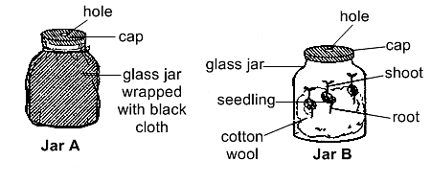
4. Elvin conducted an experiment on the germination of seeds using the apparatus shown below.

Elvin placed three green bean seeds each in two identical glass jars, A and B, lined with an equal amount of wet cotton wool. Jar A was wrapped with a piece of black cloth while Jar B was NOT. Both set-ups were left in the garden.
What was the aim of Elvin’s experiment?
________________________________________________________________
________________________________________________________________
B. (Experiment to find the property/characteristic of an object of material)

This kind of question is a little different.

Raymond cut 4 strips of materials of the same length. She dipped the end of the four strips into a dish of coloured water. After that, she measured the distance that the coloured water had travelled up each material.
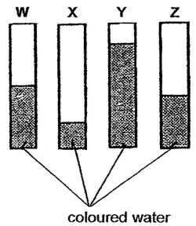

a) What is the aim of the experiment?
b) From the experiment results, which material is the best for making a bath
towel? Explain your answer.

Changed Variable: the type of material
Observed Result: the distance that coloured water travelled up the material

However, The Aim of experiment is NOT:
To find out if the type of material affects the distance that coloured water travelled up the material.

These questions expect you to INFER the property that is being tested.

“The distance that coloured water travelled up the material” is referring to how well the material can absorb water.

So the Aim is:
a) To find out which material can absorb water the best / is the most absorbent.
b) Material Y. MATERIAL Y can absorb the MOST water.
(do not mention ‘a bath towel must be able to absorb the most water’)
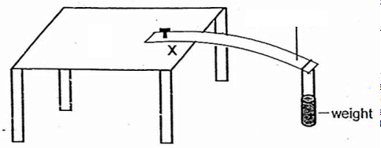
1. Doris prepared the set up shown below. She secured one end of each type of plastic strip on top of a table at point X and put a weight on the other end.
Plastic Strip
Distance
measured

Material | Distance measured (cm)
A | 5
B | 14
C | 8
Doris measured the distance that the plastic strip had bent away from its original position.
The results can be seen in the table.

a) What is the aim of the experiment?
________________________________________________________________
b) Which material is the most flexible? Give a reason for your answer.
________________________________________________________________
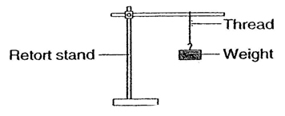
2. Benny conducted an experiment using four different materials used for making threads. Each thread had the same length and thickness. He hung a weight to the thread and increased the weight until the thread broke.

What was the aim of Benny’s experiment?
________________________________________________________________
________________________________________________________________
Morning Remediation
Primary 4 Science
Aim of Experiment / Variables
Answer Key
A. 1.
All variables are the same except for the place where the plant is grown.
What is the difference between the plant grown in the garden and the one kept in the house?
AMOUNT OF SUNLIGHT!
Therefore, changed variable = amount of sunlight the plant receives
Observed result = the height of plant growth of the plant.
(a) To find out if the amount of sunlight received affects the growth of plants.
(b) The plant did not have enough light to make food to help it grow.
(cannot accept “did not have light” – there is light in the house, but not enough light.)
A. 2.
All variables are kept the same except for the length of the magnet.
Number of paper clips attracted show the strength of the magnet.
Therefore,
(a) To find out if the length of a magnet affects the number of paper clips attracted
Or
To find out if the length of a magnet affects the strength of a magnet.
(b) D A B C
The more paper clips picked up, the stronger the magnet.

A. 3.
To find out if the presence of moisture affects the growth of mould.
OR
*To find out if water is needed for mould to grow.
Do not accept – “to find out if the amount of water affects the growth of mould” because in this experiment, one set up had water, the other had completely no water. It is the variable changed is the presence of water rather than the amount of water.

A. 4.
Every variable is kept the same except for the presence of the black cloth around the jar.
Wrapping the black cloth around the jar prevents any sunlight from getting to the seeds.
So the Changed variable is the presence of sunlight.
The observed result is the germination of seeds.
So, the aim is:
To find out if the presence of sunlight affects the germination of seeds.
OR
*To find out if sunlight is needed for the germination of seeds.
Do not accept – “to find out if the amount of light affects the germination of seeds. There was no variety of light intensity. Only, Have light or NO light.

*Questions 3 and 4 are unique, because the variable they test is either present or absent, so the aim could be:
To find out if ___Variable_____ is needed for __Result to be observed___.
B. 1.
Changed Variable = type of plastic strip
Observed result = amount that the strip bends = How flexible it is.
To find out which type of plastic strip is the most flexible
It will sound weird to say : To find out which type of plastic strip affects the amount that the plastic strip bends.
This experiment clearly is trying to compare how flexible one material is compare to another.

B. 2.
All the variables are same except for the type of material of thread.
When it mentions that the weight was increased until the thread broke, it suggested that the experiment was trying to find how much weight the thread can withstand before breaking. = Strength of the material.
Therefore,
To find out which type of material is the strongest.
Once again, it is a comparison on the strength of the materials, and not so much about how the changing of variable would affect some result.

-end-

