Morning Remediation

Primary 4 Science

Explaining, Suggesting, Reasoning

Name: ________________________ ______ Date: ________________

**A. Question-type**

**Example**

May bought a potted plant from a nursery. She brought it home and placed it beside the window. She noticed that the plant grew towards the window. She turned the pot around and the plant again grew towards the window.

**Explain/Suggest/Give a reason** why the plant kept growing towards the window.

Students will write:

* The plant wanted to get sunlight.
* The plant needed the sunlight
* The plant grows towards sunlight.
* The plant respond to changes.

These are **NOT** the answers that the question requires.

The question wants an explanation. It requires that you support your statement with a reason, with concepts, with the understanding that you have. You need to answer WHY? and SO? questions.

Model Answer: The plant was trying **to get more sunlight** as it **needs light to make food** (for survival and growth).

The answer shows an understanding that there is light in the room, but the plant grows towards the window because there is MORE light there. It also gives a simple reason WHY it needs light. The words in brackets are not necessary but they make the answer very clear and complete.

1. Mary bought new cleaning sponges to clean the outer surface of the window from inside the room as shown in the diagram below.  
  
She has to hold the handle of the cleaning sponge which is on the inner surface of the window and slide it up and down in order to use the cleaning sponges. The two cleaning sponges will move together.

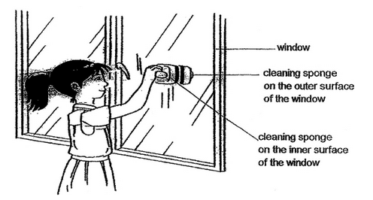

Explain clearly why the two cleaning sponges were able to move at the same time helping Mary clean the outer surface of the window.  
   
________________________________________________________________  
   
________________________________________________________________

2. Tom set up as experiment as shown below.

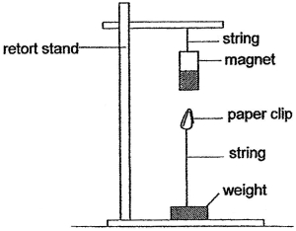

When the paper clip was placed near the magnet as shown above, the paper clip remained suspended in the air. Explain why.  
   
________________________________________________________________  
   
________________________________________________________________

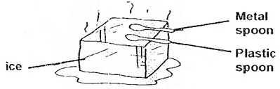3. A metal spoon and a plastic spoon are both placed on a block of ice as shown in the diagram below.

Explain why the metal spoon feels colder than the plastic spoon.   
  
________________________________________________________________  
  
________________________________________________________________

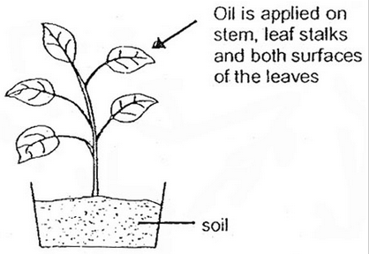4. John spread a layer of oil on the stem, leaf stalks and both surfaces of the leaves of the plant. The plant was then placed in the sun and watered every day.

The plant died after two weeks. Suggest a reason why the plant died.   
  
________________________________________________________________  
  
________________________________________________________________

5. Peter placed four things into four separate tanks A,B,C and D. He placed 100g of food and 100ml of water into each tank.

At the end of two days, he recorded the amount of food and water left in each tank.

|  |  |  |
| --- | --- | --- |
| Tank | Amount of food left (g) | Amount of water left (ml) |
| A | 70 | 20 |
| B | 20 | 30 |
| C | 100 | 100 |
| D | 0 | 0 |

Which tank most likely contained a non-living thing? Explain your answer.  
   
________________________________________________________________

**Answers:**

1. Both the cleaning sponges contained magnets and their unlike poles are facing each other so that they attract. The glass is a non magnetic material which allows magnetism to pass through.

2. The paper clip is magnetic and can be attracted by the magnet.

3. Metal is a better conductor of heat than plastic and loses heat more rapidly to the cold ice so it feels colder.

4. The oil prevents the plant from taking in carbon dioxide and it cannot photosynthesize to make food / The plant could not take in oxygen for respiration.

5. Tank C. The amount of food and water was not changed at all meaning that the thing in Tank C did not need food or water unlike living things.

