Morning Remediation

Primary 4 Science

Similarities and Differences in Comparison

Name: ________________________ ______ Date: ________________

**A. Identifying the Groups of some often wrongly classified animals**

Write (in the box):

**M** if the animal is a Mammal,

**B** if the animal is a Bird,

**F** if the animal is a Fish,

**I** if the animal is an Insect

|  |  |  |  |
| --- | --- | --- | --- |
| Animal | M/F/B/I | Animal | M/F/B/I |
| Platypus |  | Kingfisher |  |
| Whale |  | Silverfish |  |
| Spiny Anteater |  | Guppy |  |
| Ostrich |  | Dolphin |  |
| Penguin |  | Bat |  |
| Shark |  | Seahorse |  |

**B. Key Characteristics of Animal Groups**

Listed below are the characteristics found in each individual animal group. However, only some characteristics are special and are only found in that group ONLY. Identify these characteristics by putting a tick in the correct box.

|  |  |  |  |  |
| --- | --- | --- | --- | --- |
| **Mammals** | |  | **Birds** | |
| **Characteristics** | Tick (√) |  | Characteristics | Tick (√) |
| Give Birth to young alive |  |  | Has feathers on its body |  |
| Have Hair on its body |  |  | Has a beak |  |
| Feed its young with milk |  |  | Has two wings and two legs |  |
|  |  |  |  |  |
| **Fish** | |  | **Insects** | |
| **Characteristics** | Tick (√) |  | **Characteristics** | Tick (√) |
| Has scales on its body |  |  | Has an exoskeleton |  |
| Breathe with gills |  |  | Has 6 legs and 2 Antennae |  |
| Swim with fins and tail |  |  | Has 3 body parts |  |
| Lay eggs |  |  | Lay eggs |  |

**C. Characteristics of Plants**

Flowering Plants reproduce by : _______________

Non-flowering Plants reproduce by: ____________

Examples of Non-flowering plants: ________________ and ________________

**D. Characteristics of Fungi**

Some plants can be similar to Fungi in the way they reproduce.

Fungi reproduce by: _______________

**E. Animals can be similar in:**

**(The Old *Bunny* Rabbit Dislikes Mashed Potato)** *B is newly added

**Type –** Mammals, Birds, Fish, Insects

**Outer Covering –** Hair, Feathers, Scales, Exoskeleton

**Body Parts –** No. of Legs, Wings/no wings, Fins/flippers, Feelers, Lungs/gills

**Reproduction –** Lay Eggs, Give Birth **Diet –** Animal eater, Plant eater, Plant and Animal Eater **Movement –** Swim, Fly, Cannot fly, hop, crawl **Place –** Live on land, Live in water

**F. Identifying Similarities and Differences**

1. Write down one **similarity** between each pair of organisms:

a) cow and grasshopper 🡪 **Both of them**_______________________________

b) bat and eagle 🡪 **Both of them**_____________________________________

c) dolphin and goldfish 🡪 **Both of them**________________________________

d) whale and guppy 🡪 **Both of them** _________________________________

e) platypus and duck 🡪 **Both of them** _________________________________

f) tree fern and toadstool 🡪 **Both of them** _____________________________

2. Write down one **difference** between each pair of organisms:

a) sunflower and mushroom:

The sunflower ___________________________________________ **BUT**

the mushroom __________________________________________.

b) guppy and goldfish:

The guppy ______________________________________________**BUT**

the goldfish _____________________________________________.

c) bat and owl:

The bat ________________________________________________ **BUT**

the owl ________________________________________________.

d) whale and guppy:

The whale _____________________________________________ **BUT**

the guppy _____________________________________________.

e) ostrich and eagle:

The ostrich _____________________________________________**BUT**

the eagle _______________________________________________.

f) animals and plants:

Animals _______________________________________________ **BUT**

Plants __________________________________________________.

**Notice how when you state a similarity, you say “Both of them _________ “**

**and when you state a difference, you use the word “but/while”?**

**G.** **Applying of Skill**

1. Look at the table below. One of the animals has been wrongly grouped.

|  |  |
| --- | --- |
| **X** | **Y** |
| Ostrich | Beetle |
| Horse | Chicken |
| Cow | Platypus |

a) Which animal has been wrongly grouped __________________________.

b) What are the headings for the two groups:

(i) X : ______________________

(ii) Y: _______________________

2. Study the diagrams below carefully .

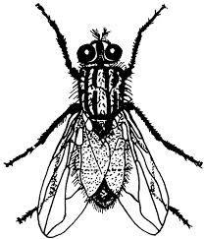

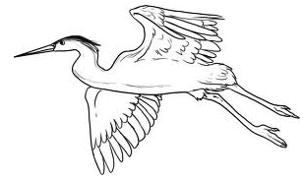

**Animal X Animal Y**

a) Based on what you see in the diagram, state one similarity and one difference between Animal X and Animal Y.

(i) Similarity: _____________________________________________________

(ii) Difference : ___________________________________________________

b) What animal group(s) do/does the two animals above belong to?

(i) Animal X : _____________________­_

(ii) Animal Y: ______________________

3. Study the diagram of a whale and a goldfish below.

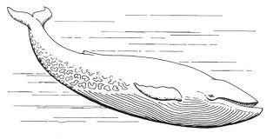

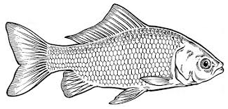

**Whale Goldfish**

State one similarity and one difference between the whale and the goldfish.

(a) Similarity: _____________________________________________________

________________________________________________________________

(b) Difference:____________________________________________________

________________________________________________________________

4. The diagram below shows a bird’s nest fern and bracket fungus.

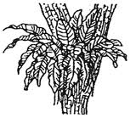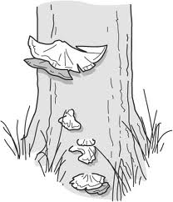

**Bird’s Nest Fern Bracket Fungus**

Based on your observation of the diagram above, what is the similarity between the Bird’s Nest Fern and the Bracket Fungus?

________________________________________________________________

________________________________________________________________



**Morning Remediation**

**Primary 4 Science**

**Similarities and Differences in Comparison**

**Answer Key**

**A.**

|  |  |  |  |
| --- | --- | --- | --- |
| Animal | M/F/B/I | Animal | M/F/B/I |
| Platypus | M | Kingfisher | B |
| Whale | M | Silverfish | I |
| Spiny Anteater | M | Guppy | F |
| Ostrich | B | Dolphin | M |
| Penguin | B | Bat | M |
| Shark | F | Seahorse | F |

**B.**

|  |  |  |  |  |
| --- | --- | --- | --- | --- |
| **Mammals** | |  | **Birds** | |
| **Characteristics** | Tick (√) |  | Characteristics | Tick (√) |
| Give Birth to young alive |  |  | Has feathers on its body | √ |
| Have Hair on its body |  |  | Has a beak |  |
| Feed its young with milk | √ |  | Has two wings and two legs |  |
|  |  |  |  |  |
| **Fish** | |  | **Insects** | |
| **Characteristics** | Tick (√) |  | **Characteristics** | Tick (√) |
| Has scales on its body |  |  | Has an exoskeleton |  |
| Breathe with gills |  |  | Has 6 legs and 2 Antennae | √ |
| Swim with fins and tail | √ |  | Has 3 body parts | √ |
| Lay eggs |  |  | Lay eggs |  |

**C.**

Seeds , Spores, Ferns, Mosses

**D.**

Spores

**F.1.**

a) cow and grasshopper 🡪 **Both of them** are plant eaters.

b) bat and eagle 🡪 **Both of them** can fly / have wings.

c) dolphin and goldfish 🡪 **Both of them** can swim / live in water.

d) whale and guppy 🡪 **Both of them** can swim / reproduce by giving birth.

e) platypus and duck 🡪 **Both of them** reproduce by laying eggs.

f) tree fern and toadstool 🡪 **Both of them** reproduce by spores.

**2.**

a) sunflower and mushroom 🡪 The sunflower reproduce by seeds but the mushroom reproduce by spores / The sunflower is a plant but the mushroom is a fungi.

b) guppy and goldfish🡪 The guppy gives birth to its young but the goldfish lays eggs.

c) bat and owl: The bat is a mammal but the owl is a bird / The bat has hair on its body but the owl is covered in feathers/ The bat gives birth to its young alive but the owl lays eggs.

d) whale and guppy: The whale is a mammal but the guppy is a fish /The whale has hair on its body but the guppy has scales. / The guppy has fins but the whale has flippers.

e) ostrich and eagle: The ostrich cannot fly but the eagle can fly.

f) animals and plants: Animals can move freely from place to place but plants cannot / Animals cannot make their own food but plants can.

**G.**

1. (a) Ostrich

(b)(i) X: Give birth

(ii) Y: Lay eggs

2. (a)(i) Both of them have wings.

(ii) Animal X has 2 legs but Animal Y has 6 legs.

(b)(i) Animal X: Bird

(ii) Animal Y: Insect

3. (a) Both of them live in the water / can swim / have tails

(b) The whale has hair on its body but the goldfish has scales / The whale

give birth to its young but the goldfish lays eggs.

4. Both of them grow on the trunk of trees. / grow on trees / live on trees.

